**Week 6 : HandsOn**

**React**

**ReactJS-HOL-1**

**Objective:**

Create a new React Application with the name “myfirstreact”, Run the application to print “welcome to the first session of React” as heading of that page.

**Steps:**

**1.Installing nodejs and npm**

**2.Install create-react-app**

npm -g create-react-app

**3. Create react application**

npx -g create-react-app myfirstreact

**4. Opening the folder in Visual Studio Code and replacing the App.js content:**

import logo from './logo.svg';

import './App.css';

function App() {

  return (

    <div className='App'>

      <h1>Welcome to the first session of React</h1>

    </div>

  );

}

export default App;

**Output:**

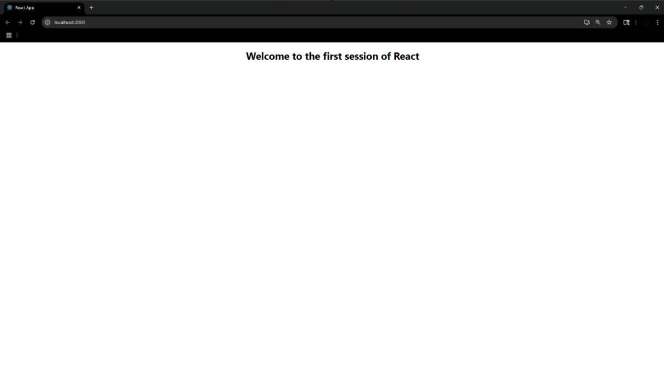

**ReactJs-HOL-2**

**Steps:**

**1.Create project named StudentApp**

npx create-react-app StudentApp

**2. Creating new folders under Compenents:**

* Home.js
* About.js
* Contact.js

**Program:**

**Home.js**

import React from 'react';

function Home() {

  return (

    <div>

      <h2>Welcome to the Home page of Student Management Portal</h2>

    </div>

  );

}

export default Home;

**About.js**

import React from 'react';

function About() {

  return (

    <div>

      <h2>Welcome to the About page of the Student Management Portal</h2>

    </div>

  );

}

export default About;

**Contact.js**

import React from 'react';

function Contact() {

  return (

    <div>

      <h2>Welcome to the Contact page of the Student Management Portal</h2>

    </div>

  );

}

export default Contact;

**3. Update App.js**

import React from 'react';

import './App.css';

import Home from './Components/Home';

import About from './Components/About';

import Contact from './Components/Contact';

function App() {

  return (

    <div className="App">

      <Home/>

      <About/>

      <Contact/>

    </div>

  );

}

export default App;

**Output:**

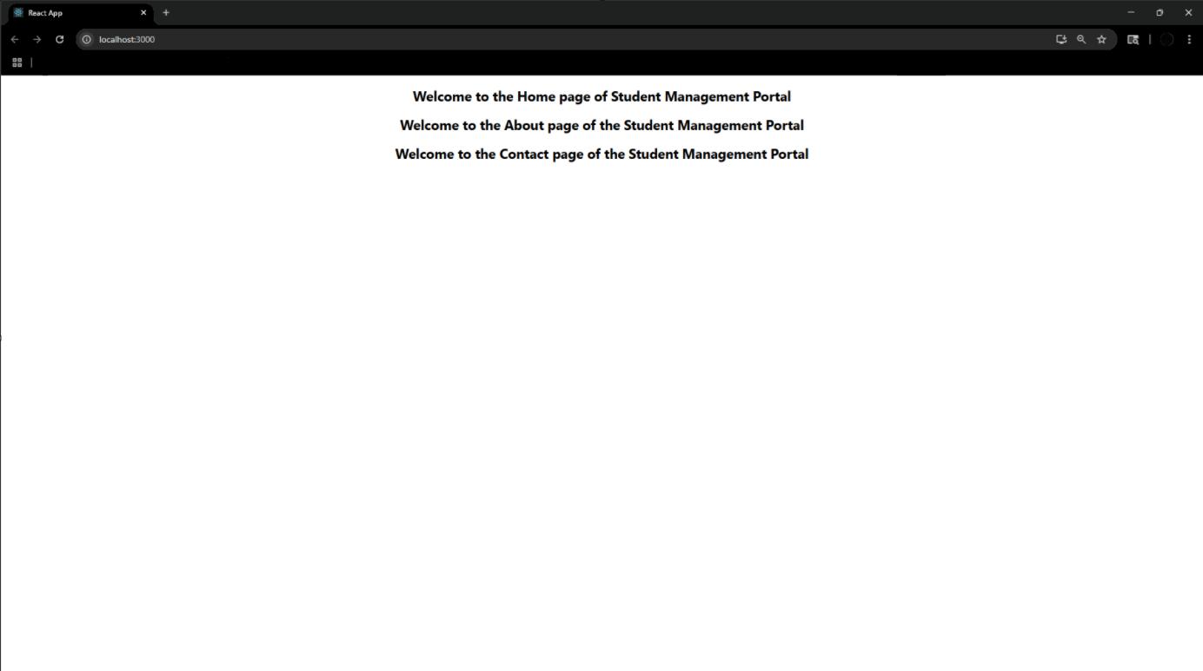

**ReactJS-HOL-3**

**Steps:**

**1.Create a new project named scorecalculatorapp**

npx create-react-app scorecalculatorapp

**Program:**

**CalculateScore.js**

import '../Stylesheets/mystyle.css'

const percentToDecimal=(decimal) => {

  return (decimal.toFixed(2) + '%');

};

const calcScore = (total, goal) => {

  return percentToDecimal(total / goal);

};

export const CalculateScore = ({ Name, School, total, goal }) => (

  <div className="formatstyle">

    <h1><font color="Brown">Student Details:</font></h1>

    <div className="Name">

      <b><span>Name: </span></b>

      <span>{Name}</span>

    </div>

    <div className="School">

      <b><span>School: </span></b>

      <span>{School}</span>

    </div>

    <div className="Total">

      <b><span>Total: </span></b>

      <span>{total}</span> Marks

    </div>

    <div className="Score">

      <b>Score: </b>

      <span>{calcScore(total, goal)}</span>

    </div>

  </div>

);

**mystyle.css**

.Name{

    font-weight: 300;

    color: blue;

}

.School{

    color:crimson

}

.Total{

    color:darkmagenta

}

.formatstyle{

    text-align: center;

    font-size: large;

}

.Score{

    color: forestgreen;

}

**App.js**

import './App.css';

import { CalculateScore } from './Components/CalculateScore';

function App() {

  return (

    <div>

      <CalculateScore

      Name={"Steeve"}

      School ={"DNV Public School"}

      total={284}

      goal={3}

      />

    </div>

  );

}

export default App;

**Output:**

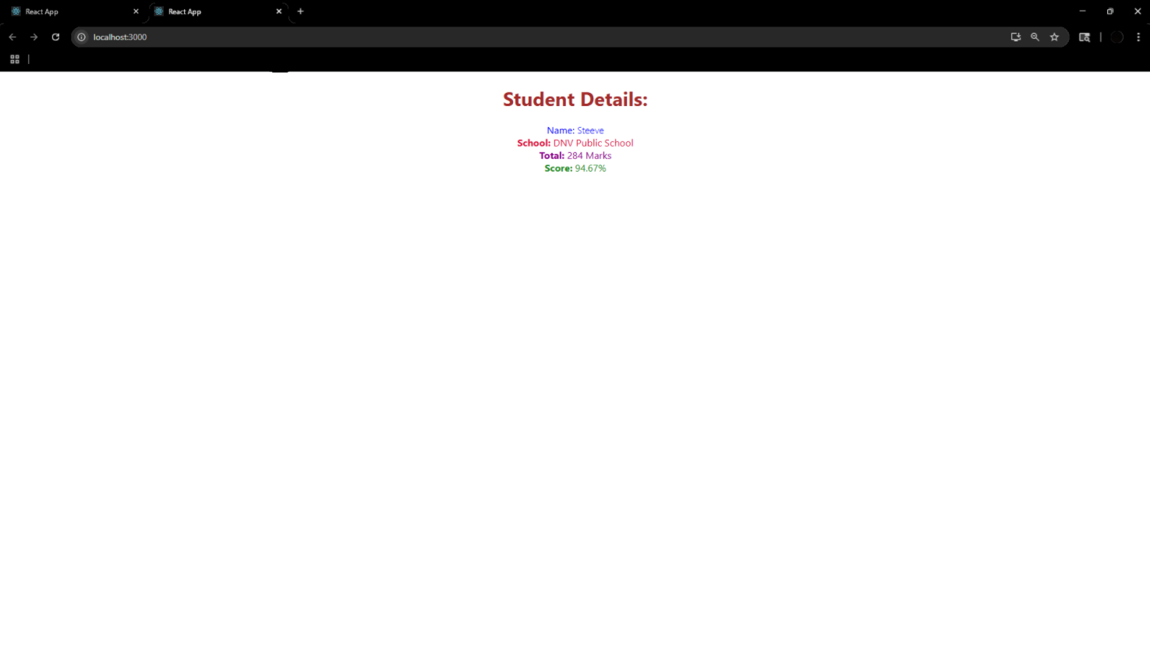

**ReactJS-HOL-4**

**Steps:**

**1.Create a new react application as blogapp**

npx create-react-app blogapp

**Program:**

**Post.js**

class Post{

    constructor(id,title,body){

        this.id=id;

        this.title=title;

        this.body=body;

    }

}

export default Post;

**Posts.js**

import React from 'react';

import Post from './Post';

class Posts extends React.Component {

  constructor(props) {

    super(props);

    this.state = {

      posts: [],

      hasError: false

    };

  }

  loadPosts() {

    fetch('https://jsonplaceholder.typicode.com/posts')

      .then(response => response.json())

      .then(data => {

        const postList = data.map(item => new Post(item.id, item.title, item.body));

        this.setState({ posts: postList });

      })

      .catch(error => {

        this.setState({ hasError: true });

        console.error('Error fetching posts:', error);

      });

  }

componentDidMount() {

    this.loadPosts();

  }

  componentDidCatch(error, info) {

    alert('An error occurred while rendering posts.');

    console.error(error, info);

  }

  render() {

    if (this.state.hasError) {

      return <h2>Something went wrong!</h2>;

    }

     return (

      <div>

        <h1>Post List</h1>

        {this.state.posts.map(post => (

          <div key={post.id} style={{ borderBottom: "1px solid #ccc", marginBottom: "10px" }}>

            <h2>{post.title}</h2>

            <p>{post.body}</p>

          </div>

        ))}

      </div>

    );

  }

}

export default Posts;

**App.js**

import React from 'react';

import Posts from './Posts';

function App() {

  return (

    <div className="App">

      <Posts />

    </div>

  );

}

export default App;

**Output:**

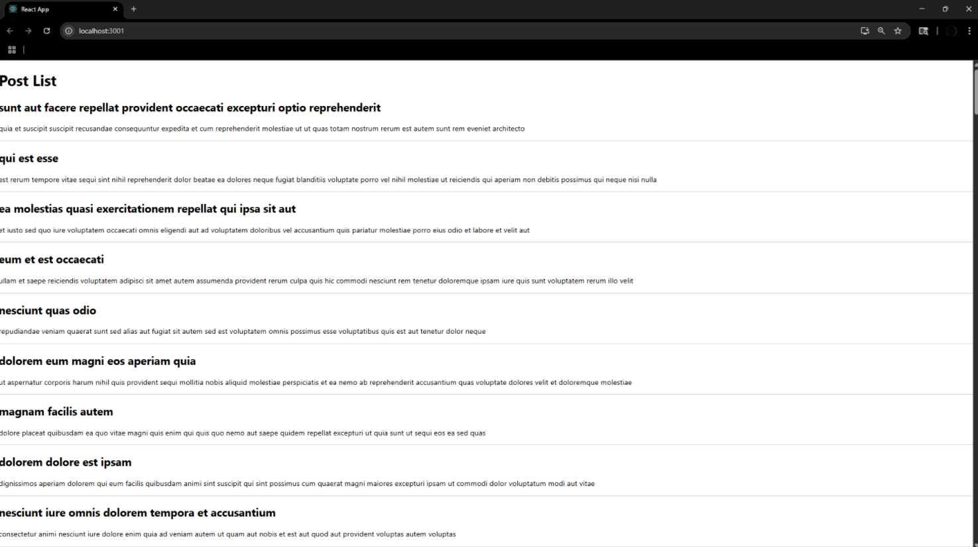

**ReactJS-HOL-5**

**Steps:**

**1.Install npm**

**Program:**

**CohortDetails.module.css**

.box {

width: 300px;

display: inline-block;

margin: 10px;

padding: 10px 20px;

border: 1px solid black;

border-radius: 10px;

}

dt {

font-weight: 500;

}

**CohortDetails.js**

import React from 'react';

import styles from './CohortDetails.module.css';

function CohortDetails(props) {

    const { cohort } = props;

const headingStyle = {

        color: cohort.currentStatus.toLowerCase() === 'ongoing' ? 'green' : 'blue'

    };

return (

        <div className={styles.box}>

            <h3 style={headingStyle}>

                {cohort.cohortCode} - <span>{cohort.technology}</span>

            </h3>

            <dl>

                <dt>Started On</dt>

                <dd>{cohort.startDate}</dd>

                <dt>Current Status</dt>

                <dd>{cohort.currentStatus}</dd>

                <dt>Coach</dt>

                <dd>{cohort.coachName}</dd>

                <dt>Trainer</dt>

                <dd>{cohort.trainerName}</dd>

            </dl>

        </div>

    );

}

export default CohortDetails;

**App .js**

import logo from './logo.svg';

import './App.css';

import { CohortsData} from './Cohort'

import CohortDetails from './CohortDetails';

function App() {

  return (

  <div>

    <h1>Cohorts Details</h1>

    {CohortsData.map(cohort => <CohortDetails cohort={cohort}/>)}

  </div>

  );

}

export default App;

**Output:**

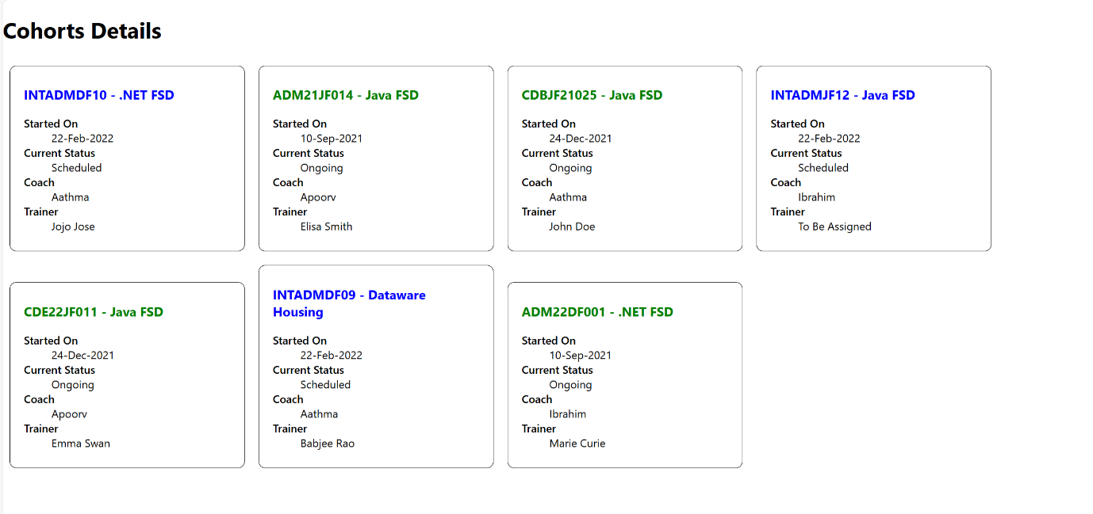

**ReactJS-HOL-6**

**Program:**

**Trainer.js**

class Trainer {

constructor(trainerId, name, email, phone, technology, skills) {

this.trainerId = trainerId;

this.name = name;

this.email = email;

this.phone = phone;

this.technology = technology;

this.skills = skills;

}

}

export default Trainer;

**trainersMock.js**

import Trainer from "./Trainer";

const trainersMock = [

  new Trainer(

    't-syed8',

    'Syed Khaleelullah',

    'khaleelullah@cognizant.com',

    '97676516962',

    '.NET',

    ['C#', 'SQL Server', 'React', '.NET Core']

  ),

  new Trainer(

    't-jojo',

    'Jojo Jose',

    'jojo@cognizant.com',

    '9897199231',

    'Java',

    ['Java', 'JSP', 'Angular', 'Spring']

  ),

  new Trainer(

    't-elisa',

    'Elisa Jones',

    'elisa@cognizant.com',

    '9871212235',

    'Python',

    ['Python', 'Django', 'Angular']

  )

];

export default trainersMock;

**TrainerList.js**

import React from 'react';

import { Link } from 'react-router-dom';

function TrainerList({ trainers }) {

  return (

    <div>

      <h2>Trainer List</h2>

      <ul>

        {trainers.map(trainer => (

          <li key={trainer.trainerId}>

            <Link to={`/trainer/${trainer.trainerId}`}>{trainer.name}</Link>

          </li>

        ))}

      </ul>

    </div>

  );

}

export default TrainerList;

**TrainerDetails.js**

import React from 'react';

import { useParams } from 'react-router-dom';

import trainersMock from './trainersMock';

function TrainerDetails() {

  const { id } = useParams();

  const trainer = trainersMock.find(t => t.trainerId === id);

  if (!trainer) return <h2>Trainer not found!</h2>;

  return (

    <div>

      <h2>{trainer.name}</h2>

      <p><strong>Email:</strong> {trainer.email}</p>

      <p><strong>Phone:</strong> {trainer.phone}</p>

      <p><strong>Technology:</strong> {trainer.technology}</p>

      <p><strong>Skills:</strong> {trainer.skills.join(', ')}</p>

    </div>

  );

}

export default TrainerDetails;

**Home.js**

import React from 'react';

function Home() {

  return (

    <div>

      <h1>Welcome to Cognizant Academy Trainer Portal</h1>

      <p>Use the navigation menu to explore our trainers.</p>

    </div>

  );

}

export default Home;

**App.js**

import React from 'react';

import { BrowserRouter, Routes, Route, Link } from 'react-router-dom';

import Home from './Home';

import TrainerList from './TrainerList';

import TrainerDetails from './TrainerDetails';

import trainersMock from './trainersMock';

function App() {

  return (

    <BrowserRouter>

      <div>

        <nav>

          <Link to="/">Home</Link> | <Link to="/trainers">Trainers</Link>

        </nav>

        <Routes>

          <Route path="/" element={<Home />} />

          <Route path="/trainers" element={<TrainerList trainers={trainersMock} />} />

          <Route path="/trainer/:id" element={<TrainerDetails />} />

        </Routes>

      </div>

    </BrowserRouter>

  );

}

export default App;

**Output:**



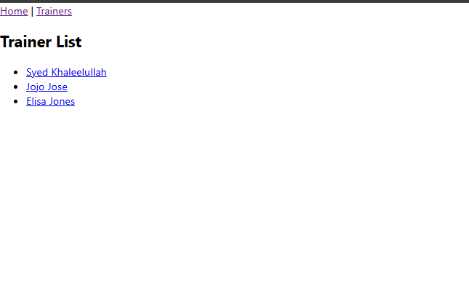



**ReactJS-HOL-7**

**Program:**

**Cart.js**

import React from 'react';

class Cart extends React.Component {

  render() {

    return (

      <div>

        <table border="1" cellPadding="10">

          <thead>

            <tr>

              <th>Item Name</th>

              <th>Price (₹)</th>

            </tr>

          </thead>

          <tbody>

            {this.props.item.map((item, index) => {

              return (

                <tr key={index}>

                  <td>{item.itemname}</td>

                  <td>{item.price}</td>

                </tr>

              );

            })}

          </tbody>

        </table>

      </div>

    );

  }

}

export default Cart;

**OnlineShopping.js**

import React from 'react';

import Cart from './Cart';

export class OnlineShopping extends React.Component {

  render() {

    const CartInfo = [

      { itemname: "Laptop", price: 80000 },

      { itemname: "TV", price: 120000 },

      { itemname: "Washing Machine", price: 50000 },

      { itemname: "Mobile", price: 30000 },

      { itemname: "Fridge", price: 70000 }

    ];

    return (

      <div className="mydiv">

        <h1>🛒 Items Ordered :</h1>

        <Cart item={CartInfo} />

      </div>

    );

  }

}

export default OnlineShopping;

**index.js**

import React from 'react';

import ReactDOM from 'react-dom/client';

import './index.css';

import OnlineShopping from './OnlineShopping';

const root = ReactDOM.createRoot(document.getElementById('root'));

root.render(<OnlineShopping />);

**Output:**

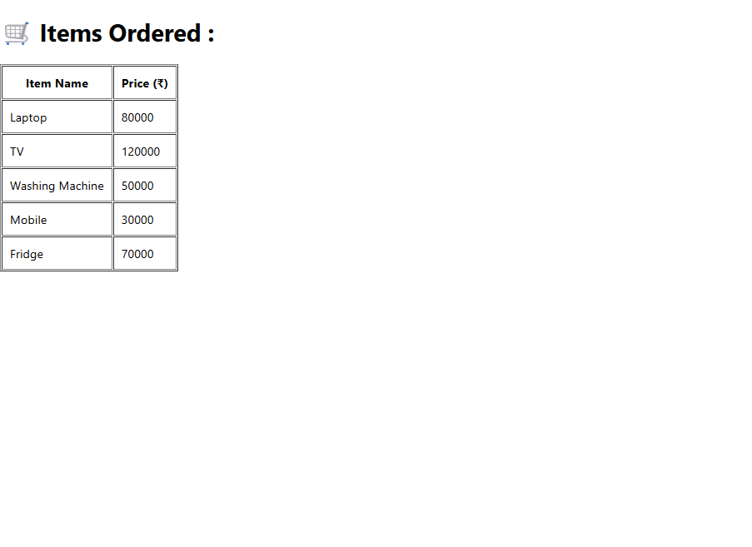

**ReactJS-HOL-8**

**Program:**

**CountPeople.js**

import React, { Component } from 'react';

class CountPeople extends Component {

  constructor(props) {

    super(props);

    this.state = {

      entryCount: 0,

      exitCount: 0

    };

  }

  UpdateEntry = () => {

    this.setState((prevState) => ({

      entryCount: prevState.entryCount + 1

    })

);

  }

  UpdateExit = () => {

    this.setState((prevState) => ({

      exitCount: prevState.exitCount + 1

    })

);

  }

 render() {

    return (

      <div style={{ textAlign: 'center', marginTop: '50px' }}>

        <h2>Mall Entry Counter</h2>

        <p>Number of people entered: {this.state.entryCount}</p>

        <p>Number of people exited: {this.state.exitCount}</p>

        <button onClick={this.UpdateEntry} style={{ marginRight: '10px' }}>Login</button>

        <button onClick={this.UpdateExit}>Exit</button>

      </div>

    );

  }

}

export default CountPeople;

**App.js**

import React from 'react';

import CountPeople from './CountPeople';

function App() {

  return (

    <div>

      <CountPeople />

    </div>

  );

}

export default App;

**Output:**

